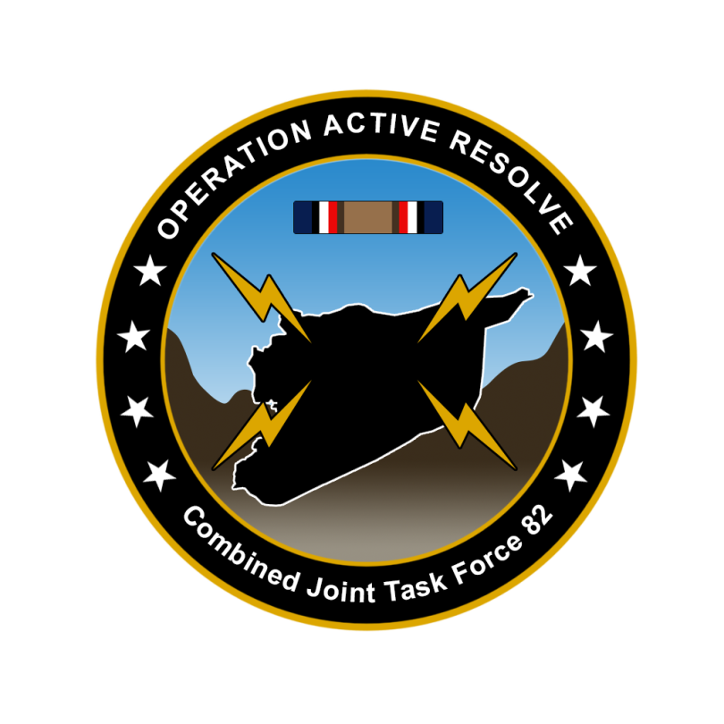

CJTF-82 DIRECTION AND GUIDANCE

D+9

This document covers the friendly situation from D+8 and provides CJTF-82 guidance to the entire force.

**Reference CombatFlite**: <https://132nd-vwing.github.io/OPAR-Brief/MISSION%20INFORMATION/Friendly_update.cf>

# SITUATION

## General situation

September 1st 2011 JFACC initiated airstrikes against Syrian forces while LCC started preparing its offensive. On D+3 LCC with its IV Corps in Sector North started its offensive.

There has been a higher Russian activity in the eastern Mediterranean than normal and this is likely due the presence and operations from CJTF-82.

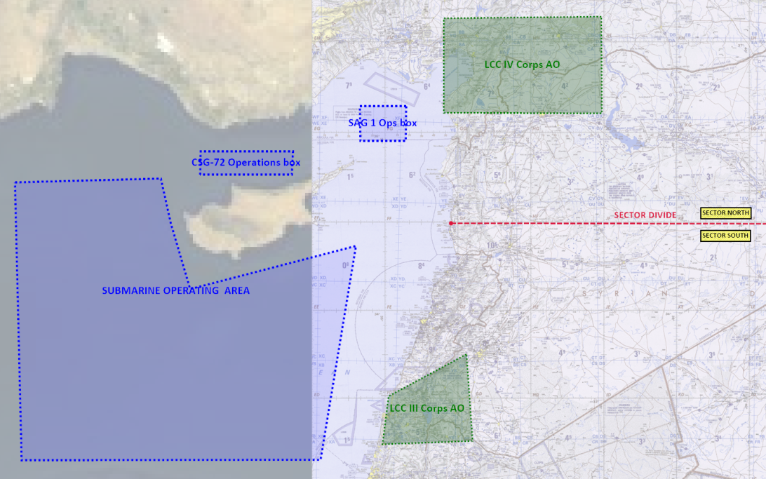

## Friendly situation

### Land Component Command (LCC)

#### IV Corps (Northern sector)

55th Division is static at the FLOT to prepare for assault into Syria in PHASE 2

56th Division is static at the FLOT to prepare for assault into Syria in PHASE 2.

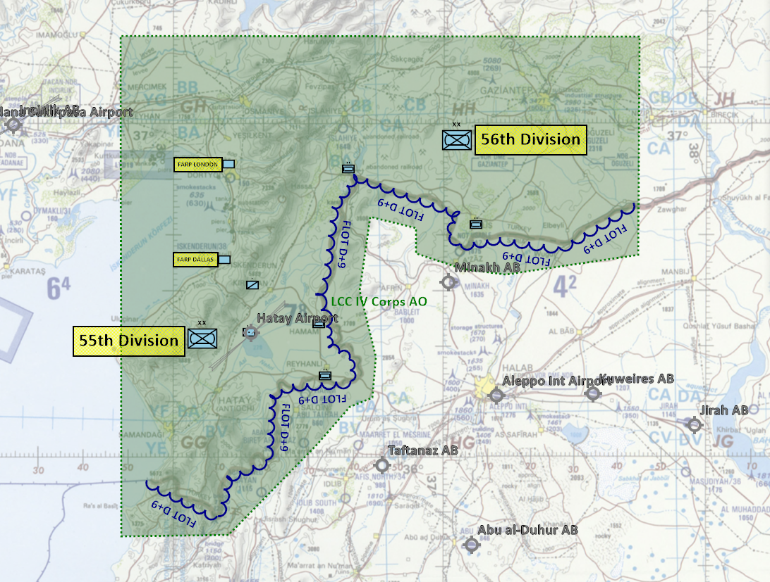

#### III Corps (southern sector)

III Corps was planned to starts its offensive at D+4. However, due to low attrition of the Syrian 3rd Corps the offensive is delayed. III Corps will start its offensive when conditions are set for starting the offensive. Conditions set for offensive start is 35% attrition on the following enemy units:

* 30th Armored Division (Syrian 3rd Corps)
* 31st Mechaniced Division (Syrian 3rd Corps)
* 32nd Motorized Division (Syrian 3rd Corps)

### Maritime Component Command (MCC)

* CSG-72 continues to support the mission from CSG-72 operations box.
* SAG-1 continues to support the mission by providing air defence coverage in the Incirlik region from SAG-1 operations box.
* CJTF MCC has been given command of a attack submarine, SSN-688 USS Los Angeles. The mission for the submarine is to deny Russia freedom of action in the eastern Mediterranean

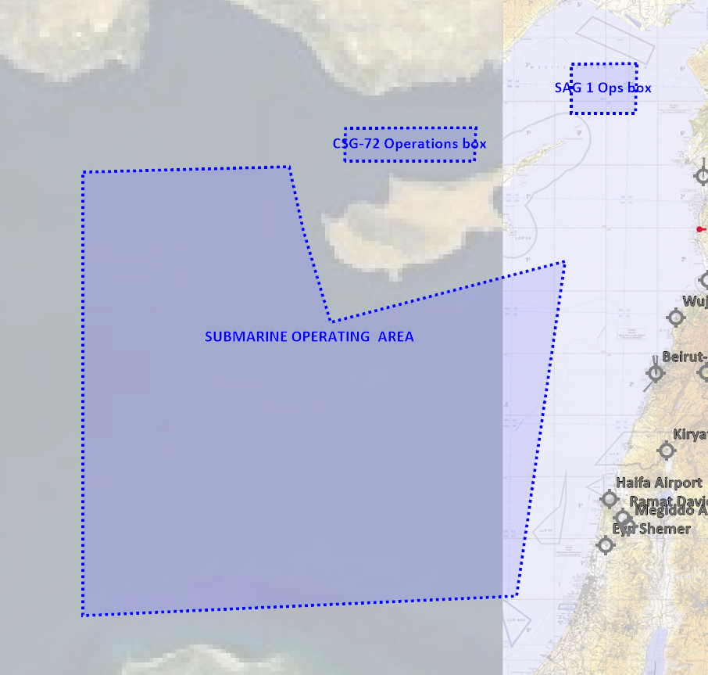

### Joint Force Air Component Command (JFACC)

* IAW JFACC JAOP and AOD’s

### Special Operations Component Command (SOCC)

* Several SOF teams have started insertion into Syria to prepare for CJTF-82 Operations order phase 2.
* SOF teams are also on standby to conduct counter terrorism missions and counter insurgency operations.

# Reported Battle Damage Assessment D+8

## IV Corps (Northern Sector)

* NSTR

## III Corps (Southern Sector)

* NSTR

# Direction and Guidance

## LCC:

* Priority of effort is on the NORTHERN sector and support of IV Corps in preparing for ground assault into SYRIA in PHASE 2.

## MCC:

* With enemy units removed from Hatay, move CSG-72 operations box further WEST to reduce transit times for allied carrier based aircraft.
* Be prepared to move SAG-1 SOUTHWEST in the eastern Mediterranean in order to create a robust threshold for any incursion of non-friendly naval forces.

## JFACC:

* Priority of effort is on establishing Air Superiority in support of LCC in the northern secort
* Start shaping for phase 2 in the operation
  + For support to LCC, support shaping effort for LCC by removing enemy long range artillery, C2, logistics and artillery

## Diplomatic situation

* Syria is declared as enemy
* Russia is declared as adversary
* Jordan is declared as neutral
* Lebanon is declared as neutral
* Turkey is declared as friendly
* Israel is declared as friendly

Only units declared as enemy can and should be engaged by CJTF forces.

**Definitions:**

Enemy: is actively opposed or hostile to CJTF and friendly forces.

Adversary: opponent in a contest, conflict, or dispute toward CJTF and friendly forces.

Neutral: not supporting or helping either side in a conflict, disagreement, etc.; impartial.